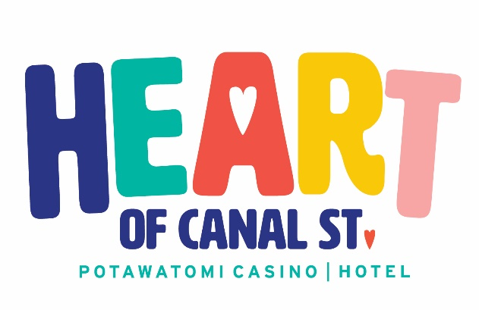

**2025 SUBMISSION GUIDELINES**

**Eligible Organizations**

* Established 501(c) (3) public charity as defined under the Internal Revenue Code and has been in existence under the IRS designated agency name for at least five years.
* Agency must be located in Dodge, Jefferson, Kenosha, Milwaukee, Ozaukee, Racine, Sheboygan, Walworth, Waukesha or Washington County.
* Must operate demonstrated programming that provides direct services to children (infant to 17 years of age) who reside in at least one of the above counties.
* Organization affirms that it is an Equal Opportunity Employer and complies with all laws and regulations prohibiting employment or other discrimination. Organization agrees not to discriminate against any employee, applicant for employment, customer, volunteer or any person eligible for services by their organization because of age, race, religion, color, handicap, sex, physical condition, developmental disability as defined in Wis. Stat. §51.01(5), sexual orientation or national origin.

**Application Requirements**

* Organization must submit a complete entry and supply all information and forms as listed in the application.

**Ineligible Organizations**

* Organizations that received $20,000 or more from Potawatomi Casino Hotel and/or Forest County Potawatomi Foundation between Oct. 1, 2024, and Sept. 30, 2025.
* Organizations that hold a position against or advocate against legal gambling.
* Military or Veterans organizations.
* Political organizations or programs such as 527 groups.
* Organizations that operate as childcare centers, daycare centers or preschools.
* Public or private schools serving kindergarten-12th grade.
* Group homes and shelters solely providing services for adults.
* Scholarship funds.
* Service club activities and all other organizations that do not solely provide services for children under 17.
* Second-party funding organizations.
* Public and private foundations, including those linked to a for-profit business or organization, and those that redistribute funds to other organizations.
* Endowments.
* Individuals participating in contests, pageants or individual appeals for services.
* Trips, tours or conferences.
* Organizations that operate out of a place of worship such as a church, temple, mosque, synagogue, etc.
* Local chapters of national organizations that primarily fund national research or that distribute funds received outside of southeast Wisconsin.
* Festivals or events without an educational experience focused on children ages 17 or younger.

**2025 SUBMISSION GUIDELINES**

**Additional Qualifiers or Restrictions**

* Only one (1) submission is allowed per organization. If organization is an umbrella company over other subsidiaries, only one submission from either the parent company or its subsidiaries will be considered/allowed. *Example*: A school or university with multiple programs/subsidiaries.
* All information submitted will become the property of Potawatomi Casino Hotel and will not be returned.
* Incomplete entries will be disqualified.
* The Heart of Canal Street Committee will screen all entries for eligibility. Potawatomi Casino Hotel management reserves the right to disqualify any organization it deems inappropriate for the program.
* Potawatomi Casino Hotel management reserves all rights and all decisions are final.

**Online Submission Requirements**

* The completed online application MUST be submitted by November 11, 2025.

**Mail-In Submission Requirements**

* The completed application packet MUST be postmarked by November 11, 2025.
* **NO HAND-DELIVERED** applications will be accepted.
* Applications should be mailed to:

**Sarah Neubauer**

**Community Engagement Manager**

**Potawatomi Casino Hotel**

**1721 W. Canal St.**

**Milwaukee, WI 53233**